CALL FOR PAPERS – The Prelude to Decolonisation

This is just a brief note to let you know that Ayesha Omar and I are arranging a conference on The Prelude to Decolonisation: the turning of the tide. Professor Peter Vale has kindly made Johannesburg Institute of Advanced Studies available for the conference (there will be no conference fee, and we envisage providing accommodation for the duration of the conference). We would be absolutely delighted to hear from any potential contributors. Please send expressions of interest to Ayesha and me, with a tentative title and abstract ([aomar@uj.ac.za](mailto:aomar@uj.ac.za) [Boucherde@cardiff.ac.uk](mailto:Boucherde@cardiff.ac.uk)) The details of the conference are as follows. Please feel free to pass-on this invitation to your contacts who may be interested.

**‘The Prelude to Decolonisation: the turning of the tide’**

**An Interdisciplinary Conference, 30th August – 1st September**

**Johannesburg Institute for Advanced Studies,**1 Tolip Street, Westdene 2092

P O Box 524, Auckland Park 2006, Johannesburg, South Africa

Tel +27 11 559 7530 / 7542

[](http://jias.joburg/wp-content/uploads/2015/12/jias-building-11.jpg)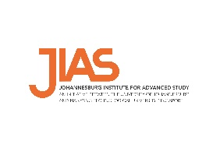

 ‘The Prelude to Decolonisation: the turning of the tide’. This is envisaged to be a comparative analysis of justifications of and responses to colonialism from the colonised, with a primary, but not exclusive focus, on Africa. The project is at once designed to articulate clearly the circumstances of and justifications for colonisation, but more importantly to retrieve the voices of indigenous opposition prior to the crescendo and irresistible force of decolonisation and postcolonialism.

The conference is organised by Professor David Boucher (Cardiff and Distinguished Visiting Professor, Johannesburg), and Dr Ayesha Omar (Johannesburg) and is sponsored by the Johannesburg Institute of Advanced Studies (JIAS).

Additional support has been provided by the University of Johannesburg and the British Academy/National Research Foundation Chair in Political Theory.